Cell Respiration: Glycolysis, TCA Cycle and ETC

Glycolysis:
Glycolysis is derived from the Greek words (glykys = sweet and lysis = splitting). It is the almost universal pathway that converts glucose into pyruvate along with the formation of nicotinamide adenine dinucleotide (NADH) and adenosine triphosphate (ATP). It primarily occurs in the cytoplasm of the cell. Glycolysis can be defined as the sequence of reactions for the breakdown of Glucose (6-carbon molecule) to two molecules of pyruvic acid (3-carbon molecule) under aerobic conditions; or lactate under anaerobic conditions along with the production of small amount of energy. This pathway was described by Embden, Meyerhof and Parnas. Hence, it is also called as Embden-Meyerhof pathway (EM pathway. In organisms that perform cellular respiration, glycolysis is the first stage of this process. However, glycolysis doesn’t require oxygen, and many anaerobic organisms—organisms that do not use oxygen—also have this pathway.
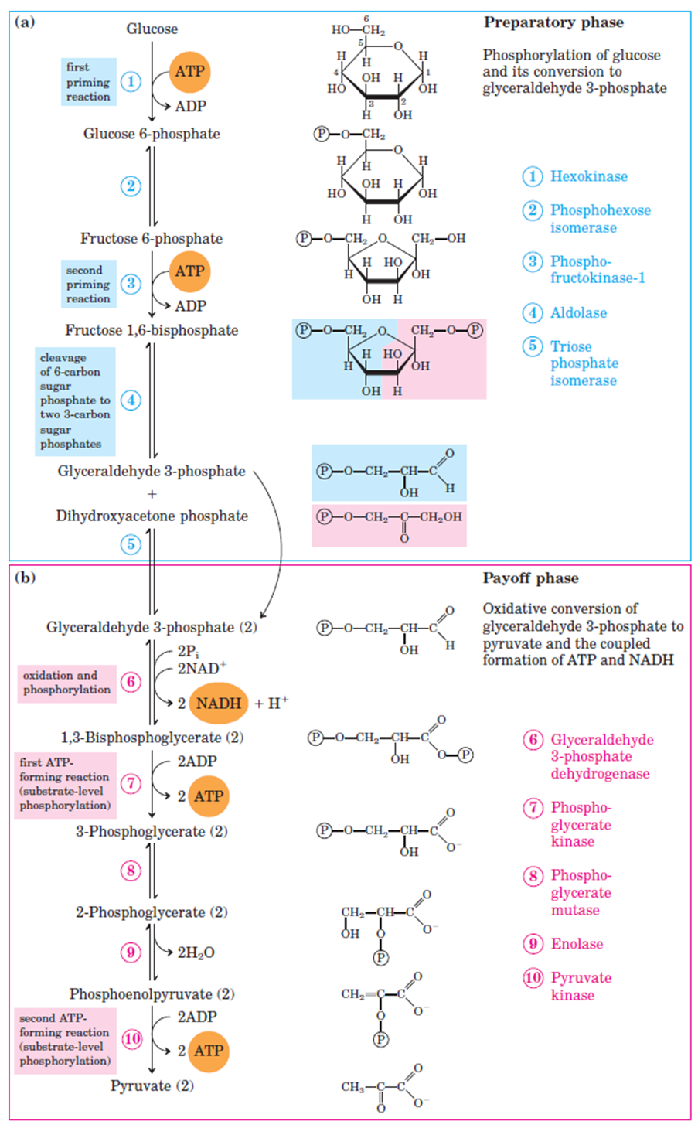

Aerobic and anerobic glycolysis
Under aerobic conditions, the pyruvate passes into the mitochondria where it is completely oxidized by O₂ into CO₂ and H₂O and its chemical energy largely conserved as ATP. Pyruvate generated via aerobic glycolysis feeds into the TCA or Krebs cycle.
In the absence of sufficient oxygen, the pyruvate is reduced by NADH via anaerobic glycolysis or fermentation to a wide range of products, routinely lactate in animals and ethanol in yeasts.

Embden-Meyerhof-Parnas glycolytic pathway
The starting molecule for glycolysis is glucose, a simple and abundant sugar found in carbohydrates, which provides the energy for most cells. Carbohydrates synthesized during photosynthesis act as the main storage molecules of solar energy. When ingested, complex carbohydrates are enzymatically hydrolyzed to monosaccharides, such as starch to D(+)-glucose.
The catabolism of glucose is the primary energy source for short-term requirements.
The remainder of this article will focus on the glycolytic pathway known as the Embden-Meyerhof-Parnas (EMP) pathway, named for its discoverers, Gustav Embden, Otto Meyerhof, and Jakub Karol Parnas. The chemical steps of the pathway are illustrated in the image to the right and via the video below.
The glycolytic pathway can be divided into two phases:
Preparatory Phase:
This phase is also called glucose activation phase. In the preparatory phase of glycolysis, two molecules of ATP are invested and the hexose chain is cleaved into two triose phosphates.
During this, phosphorylation of glucose and it’s conversion to glyceraldehyde-3-phosphate take place. The steps 1, 2, 3, 4 and 5 together are called as the preparatory phase.
Payoff Phase:
This phase is also called energy extraction phase. During this phase, conversion of glyceraldehyde-3-phophate to pyruvate and the coupled formation of ATP take place.
Because Glucose is split to yield two molecules of D-Glyceraldehyde-3-phosphate, each step in the payoff phase occurs twice per molecule of glucose. The steps after 5 constitute payoff phase.
Steps of glycolysis:
Preparatory Phase:
- Phosphorylation of glucose: D(+)-Glucose is phosphorylated with ATP to give glucose-6-phosphate.
- Isomerization of glucose-6-P to fructose-6-P: The isomerization of glucose-6-phosphate in the second reaction to fructose-6-phosphate occurs via ring-opening and subsequent keto-enol-tautomerization.
- Phosphorylation of fructose-6-P: The third reaction is another phosphorylation with ATP, whereby fructose-6-phosphate is converted to fructose-1,6-bisphosphate
- Fructose-1,6-bisphosphate to glyceraldehyde phosphate and dihydroxyacetone phosphate. A key branching reaction is the fourth reaction: a ring-opening reaction of fructose-1,6-bisphosphate, which is cleaved in a retro-aldol reaction into D-glyceraldehyde-3-phosphate, and dihydroxyacetone phosphate.
- Isomerization of dihydroxyacetone-P to glyceraldehyde-P: The branch via dihydroxyacetonephosphate is channelled back into D-glyceraldehyde-3-phosphate in the fifth reaction by an isomerization.
Payoff Phase:
- Glyceraldehyde phosphate oxidation & phosphorylation to 1,3-bisphosphoglycerate: In the sixth reaction, the combined D-glyceraldehyde- 3-phosphate from both routes is oxidized at the C1 to a carboxylic acid and then phosphorylated in the 1-position to yield 1,3-bisphospho-D-glycerate.
- ATP formation: This phosphate group in the 1-position is transferred in the seventh reaction from the carboxyl group to ADP to give 3-phospho-D-glycerate.
- 3-Phosphoglycerate to 2-phosphoglycerate: The eighth reaction is an isomerization of 3-phospho-D-glycerate to 2-phospho-D-glycerate.
- 2-Phosphoglycerate to phosphonenolpyruvate: The next metabolite, phosphoenolpyruvate, is formed in a dehydration reaction from 2-phospho-D-glycerate.
- Formation of pyruvate & ATP: The glycolysis pathway from D(+)-glucose to two molecules of pyruvate is concluded by the tenth reaction, which transfers a phosphate group from phosphoenolpyruvate to ADP, thereby giving ATP and pyruvate.

Krebs (Citric Acid) Cycle:

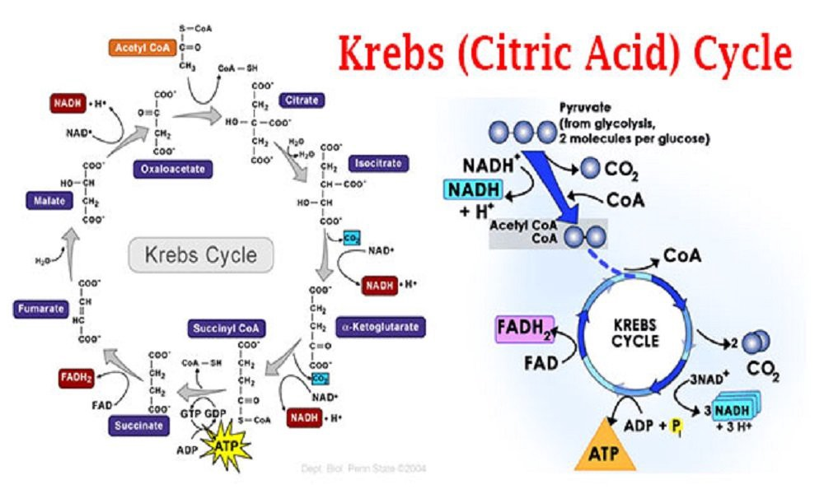

It is also known as Tri-Carboxylic Acid (TCA) cycle. In prokaryotic cells, the citric acid cycle occurs in the cytoplasm; in eukaryotic cells, the citric acid cycle takes place in the matrix of the mitochondria.
The cycle was first elucidated by scientist “Sir Hans Adolf Krebs” (1900 to 1981). He shared the Nobel Prize for physiology and Medicine in 1953 with Fritz Albert Lipmann, the father of ATP cycle.
The process oxidises glucose derivatives, fatty acids and amino acids to carbon dioxide (CO2) through a series of enzyme controlled steps. The purpose of the Krebs Cycle is to collect (eight) high-energy electrons from these fuels by oxidising them, which are transported by activated carriers NADH and FADH2 to the electron transport chain. The Krebs Cycle is also the source for the precursors of many other molecules and is, therefore, an amphibolic pathway (meaning it is both anabolic and catabolic).
Reaction 1: Formation of Citrate
The first reaction of the cycle is the condensation of acetyl-CoA with oxaloacetate to form citrate, catalyzed by citrate synthase. Once oxaloacetate is joined with acetyl-CoA, a water molecule attacks the acetyl leading to the release of coenzyme A from the complex.
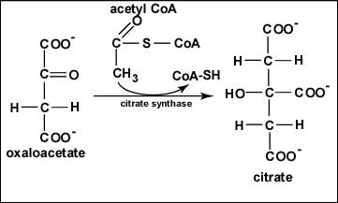
Formation of Citrate
Reaction 2: Formation of Isocitrate
The citrate is rearranged to form an isomeric form, isocitrate by an enzyme acontinase.
In this reaction, a water molecule is removed from the citric acid and then put back on in another location. The overall effect of this conversion is that the –OH group is moved from the 3′ to the 4′ position on the molecule. This transformation yields the molecule isocitrate.
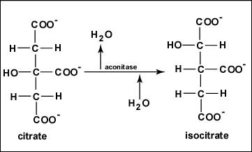
Reaction-2-Formation-of-Isocitrate
Reaction 3: Oxidation of Isocitrate to α-Ketoglutarate
In this step, isocitrate dehydrogenase catalyzes oxidative decarboxylation of isocitrate to form α-ketoglutarate.
In the reaction, generation of NADH from NAD is seen. The enzyme isocitrate dehydrogenase catalyzes the oxidation of the –OH group at the 4′ position of isocitrate to yield an intermediate which then has a carbon dioxide molecule removed from it to yield alpha-ketoglutarate.
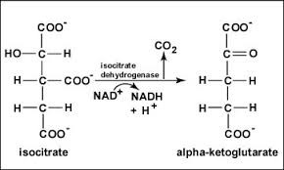
Reaction 3 Oxidation of Isocitrate to α-Ketoglutarate
Reaction 4: Oxidation of α-Ketoglutarate to Succinyl-CoA
Alpha-ketoglutarate is oxidized, carbon dioxide is removed, and coenzyme A is added to form the 4-carbon compound succinyl-CoA. During this oxidation, NAD+ is reduced to NADH + H+. The enzyme that catalyzes this reaction is alpha-ketoglutarate dehydrogenase.
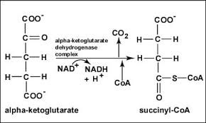
Reaction 4 Oxidation of α-Ketoglutarate to Succinyl-CoA

Reaction 5: Conversion of Succinyl-CoA to Succinate
CoA is removed from succinyl-CoA to produce succinate.
The energy released is used to make guanosine triphosphate (GTP) from guanosine diphosphate (GDP) and Pi by substrate-level phosphorylation. GTP can then be used to make ATP. The enzyme succinyl-CoA synthase catalyzes this reaction of the citric acid cycle.
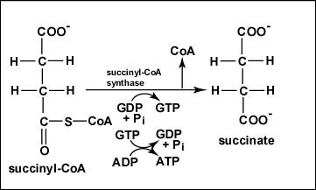
Reaction 5 Conversion of Succinyl-CoA to Succinate
Reaction 6: Oxidation of Succinate to Fumarate
Succinate is oxidized to fumarate.
During this oxidation, FAD is reduced to FADH2. The enzyme succinate dehydrogenase catalyzes the removal of two hydrogens from succinate.
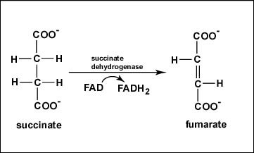
Reaction 6 Oxidation of Succinate to Fumarate
Reaction 7: Hydration of Fumarate to Malate
The reversible hydration of fumarate to L-malate is catalyzed by fumarase (fumarate hydratase).
Fumarase continues the rearrangement process by adding Hydrogen and Oxygen back into the substrate that had been previously removed.
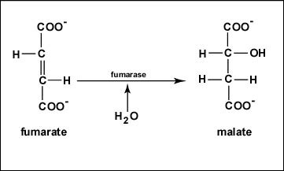
Reaction 7 Hydration of Fumarate to Malate
Reaction 8: Oxidation of Malate to Oxaloacetate
Malate is oxidized to produce oxaloacetate, the starting compound of the citric acid cycle by malate dehydrogenase. During this oxidation, NAD+ is reduced to NADH + H+.
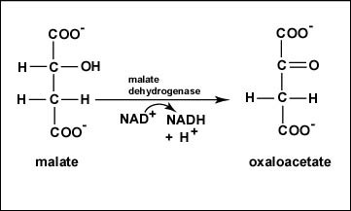
Reaction 8 Oxidation of Malate to Oxaloacetate
ATP Generation
Total ATP = 12 ATP
3 NAD+ = 9 ATP
1 FAD = 2 ATP
1 ATP = 1 ATP
Reviewing the whole process, the Krebs cycle primarily transforms the acetyl group and water, into carbon dioxide and energized forms of the other reactants.
Significance of Krebs CycleIntermediate compounds formed during Krebs cycle are used for the synthesis of biomolecules like amino acids, nucleotides, chlorophyll, cytochromes and fats etc.Intermediate like succinyl CoA takes part in the formation of chlorophyll.Amino Acids are formed from α- Ketoglutaric acid, pyruvic acids and oxaloacetic acid.Krebs cycle (citric Acid cycle) releases plenty of energy (ATP) required for various metabolic activities of cell.By this cycle, carbon skeleton are got, which are used in process of growth and for maintaining the cells.

Electron Transport Chain
The electron transport chain is comprised of a series of enzymatic reactions within the inner membrane of the mitochondria, which are cell organelles that release and store energy for all physiological needs.
As electrons are passed through the chain by a series of oxidation-reduction reactions, energy is released, creating a gradient of hydrogen ions, or protons, across the membrane. The proton gradient provides energy to make ATP, which is used in oxidative phosphorylation.
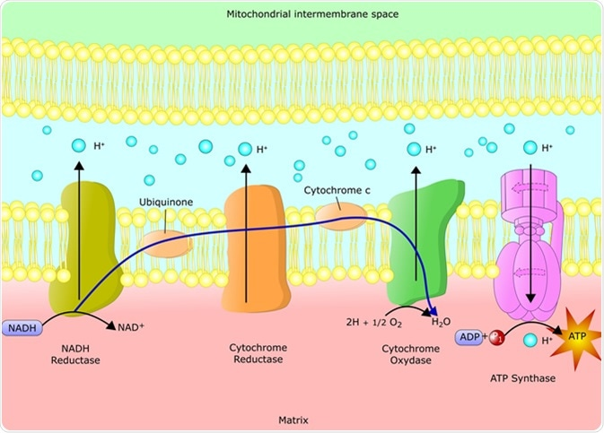
Schematic representation of the electron transfer chain via chemiosmotic reactions. Image Credit: Ellepigrafica / Shutterstock
The reactions of the electron transport chain are carried out by a series of membrane proteins and organic molecules. They are arranged in four complexes. In eukaryotes, the electron transport chain is located in the inner mitochondrial membrane. In prokaryotes, it is located within the plasma membrane.
Electrons move through the electron transport chain from a higher to lower energy state. Energy release moves protons through channels in the membrane proteins, moving them into the inner membrane space. This leads to a buildup of positively charged protons, which creates an electrical potential across the membrane.
The reactions of the electron transport chain involve several large membrane protein complexes within the inner mitochondrial membrane. Some are described below.

The NADH Dehydrogenase Complex
The NADH dehydrogenase complex (Complex I) contains more than 40 polypeptides. It transfers electrons from NADH to coenzyme Q10. The reaction begins when NADH binds to Complex I, transferring two electrons to the flavin mononucleotide (FMN) prosthetic group, resulting in the formation of FMNH2. The electrons are then transferred through iron-sulfur clusters to coenzyme Q10. The change in redox state of the protein induces a conformational change, causing the four hydrogen ions to be pumped into the inner membrane space. Four protons are thus transported across the membrane in the reaction.

Succinate Dehydrogenase (Complex II)
Succinate dehydrogenase, also known as succinate-CoQ reductase, receives electrons into the quinone pool from succinate and transfers them to to Q. Complex II has four subunits. Complex II operates parallel to Complex I. However, no protons are transported into the intermembrane space. This enzyme also takes part in the tricarboxylic acid (citric acid) cycle as well.

The Cytochrome b-c1 Complex
The cytochrome b-c1 complex (Complex III), has 11 polypeptide chains and functions as a dimer, and is also known as coenzyme Q: cytochrome c-oxidoreductase or cytochrome c reductase. Three heme groups are found within each monomer, bound to cytochromes and an iron-sulfur protein. The function of the b-c1 complex is via a Q-cycle mechanism. It catalyzes the reduction of cytochrome c by the oxidation of coenzyme Q while pumping 4 protons from the mitochondrial matrix to the intermembrane space. Mutations of Complex III are associated with exercise intolerance and some multisystem disorders.

Cytochrome c Oxidase
Cytochrome c oxidase is the last step in the electron transport chain. It functions as s dimer, with each monomer containing 13 different polypeptide chains, including two cytochromes and two copper atoms. It accepts two electrons from two cytochrome c molecules and passes them four at a time to oxygen. Mutations of cytochrome c oxidase can lead to severe metabolic disorders. The cytochrome oxidase reaction uses about 90 percent of the oxygen taken up by most cells.

Uncoupling
Electron transport can be uncoupled from ATP synthesis through the use of certain agents or some natural processes. Some specialized fat cells, known as brown fat, uncouple the electron transport chain in order to dissipate the energy as heat. This is accomplished through a transport protein that moves protons down the electrochemical gradient, bypassing ATP synthase. The cells oxidize their fat stores rapidly, producing heat. Hibernating animals and newborn human babies have brown fat.

