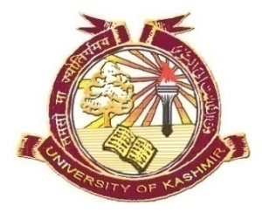
Post-Graduate Department of Zoology
School of Biological Sciences
University of Kashmir, Srinagar

Dr. Maharaj Krishan Raina

With profound grief, sorrow and heavy heart Dr. M. K. Raina, former Professor and Head Department of Zoology has lost his battle to Covid-19 at Batra Hospital, Jammu on 12th May 2021.
The Department of Zoology is deeply bereaved on the sad demise of Dr. Raina and offers tearful homage to this great teacher. May the soul of the deceased rest in peace and may the family have the courage to bear this irreparable loss.
Dr. Raina was a wonderful teacher and headed the Department for pretty long time. In his death, we have lost a great teacher, a dedicated researcher and an able administrator. His contributions to Zoology shall be remembered for all times to come.

